 | Application for an Extension to Submit a Revised Thesis for Second Examination  (including creative equivalent) |  |  | 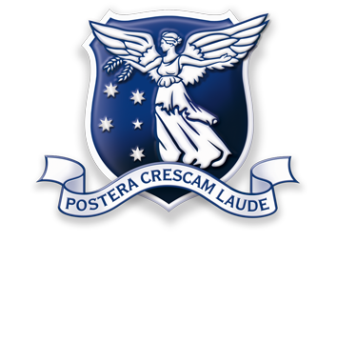
Students are expected to submit the revised thesis for second examination within 18 months for a Doctoral Degree (Research) thesis and within 12 months for a Masters Degree (Research) thesis. In exceptional circumstances, the Chair of Research Higher Degrees Committee may grant a further extension. If a student does not submit the revised thesis by the expiration of the final deadline, a fail result will be awarded.

Students applying for an extension must attach a complete thesis outline (max 4 pages) of how the thesis will be revised within the extended period. This form should be lodged to the Examinations Office once all sections have been completed. The completed form should be submitted to: gr-exams@unimelb.edu.au

It is important that your postal address and contact details are current. If your details change please update my.unimelb. Access to my.unimelb can be reinstated via the Special Access to University Facilities form:
gradresearch.unimelb.edu.au/__data/assets/file/0009/1492668/Reinstatement_IT_services.doc

The University’s privacy statement can be viewed at unimelb.edu.au/unisec/privacy/studentinfo.html

student details
Student no. and Student Name
Degree

student Extension request
I am requesting an extension to:
(enter dd/mm/yy)
Reasons:
Name | Signature | Date (dd/mm/yy)

supervisor comments
Reasons:
Name | Signature | Date (dd/mm/yy)
If a student does not submit their revised thesis by the expiration of the final deadline, a fail result will be awarded. If the applied extension exceeds the total period permitted do you support this as a final extension? |  | Yes No

chair of examiners comments
Name | Signature | Date (dd/mm/yy)

